2015-2016 …………………… SECONDARY SCHOOL 2nd TERM 1st WRITTEN EXAM FOR 7th GRADES
NAME & SURNAME : DATE : … / … / 2016
CLASS & NO : MARK :
_______________________________________________________________________________________________

- Sue : What kind of TV programs do you prefer watching?
Tim : I prefer watching _______ .

- quiz shows
- sit-coms
- reality shows
- documentaries

- “Contains behavior that may create negative example.” ifadesine uygun seçeneği işaretleyiniz.
- B)
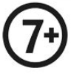
- D)

- My favorite TV serial starts ____________ Friday evening _________ 8.00.

- on / at
- in / on
- at / at
- on / in

- Hurray! We are going to a/n _________ party tonight. It’s really enjoyable.

- halloween B) fancy dress
- pyjamas D) wedding

5. Jack : What a nice party! Would you like to have some lemonade?
Sally : Yes, - - - -, please.

- one C) a few
- a little D) any

6. ve 7. soruları tabloya göre cevaplandırınız.
 | The News | Sit-coms | Talk  Shows | Soap Operas
Oliver | ü | ý | ý | ü
Scarlet | ü | ý | ü | ý
Belinda | ý | ü | ý | ý
Oscar | ü | ý | ü | ý
Pamela | ý | ü | ý | ü
- Which one is true?

- Oliver prefers talk shows to the news.
- Scarlet likes watching sit-coms.
- Oscar doesn’t like watching soap operas.
- Pamela prefers the news to talk shows.

- Who likes watching factual programs?

- Belinda and Oscar
- Pamela and Belinda
- Oliver, Scarlet and Oscar
- Scarlet, Belinda and Oscar
It’s Peter’s birthday tomorrow.
______________ ?
Great idea!
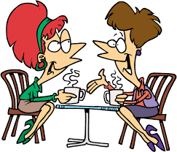

- Where will we give the party
- Do you like giving parties for people
- Could you explain that once more, please
- How about giving a surprise party for him

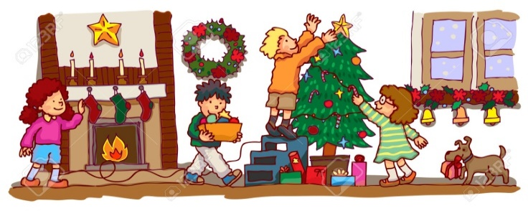
- What are they doing?
- They’re preparing the guest list.
- They’re buying presents.
- They’re decorating the room.
- They’re ordering the beverages.
- I always _________ before blowing out the candles on my birthday cake but they don’t come true.

- make a wish B) manage money
- take care D) worry about

- What is he doing ?
He is _______ .

- preparing the food
- wearing his costume
- decorating the room
- preparing the guest list

- Mom: We have _________ eggs and ________ floor, but we haven’t got _________ apples to make an apple pie. Why don’t you go and buy some apples, dear?
Son: OK. mom. I’m going right now.

- a little/ some / any C) a few/ a little/ any
- any / some / a little D) some / some / a few

- Trevor is turning 4 tonight. So, there are 4 (four) ________ on his birthday cake.

- cookies
- beverages
- candles
- invitations
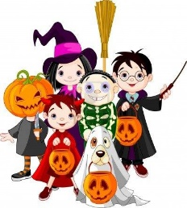
- They are going to a/n ______ party tonight.
- halloween
- wedding
- birthday
- pyjamas

- Jack : Mom, can I invite all my friends to my birthday party?
Mom : Oh, dear. - - - -. It’ll be too crowded. You should invite your close friends.

- That’s not a good idea
- I agree with you
- I hope you enjoy the party
- That sounds great
- I’m a superstitious person. I believe ____________ brings good luck.

- breaking a mirror
- finding a four-leaf clover
- walking under a ladder
- opening an umbrella indoors

- Which one symbolizes bad luck?
- B)

- D)

- Oscar : Mom, I want to wear a pirate costume for the ______ tomorrow.
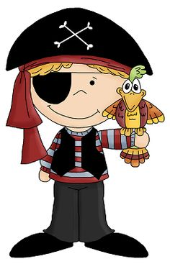
Mom : Why not? Let’s go ond buy one, then.
Oscar : You’re great, mom.

- wedding ceremony
- birthday organization
- fancy dress party
- party organization
- Aşağıdaki eşleştirmelerden hangisi yanlıştır?
 | 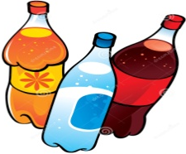
- Candles | - Beverages
- pasta | - Invitation card

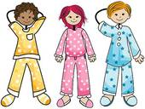
- Last night, I joined Diana’s ----. I enjoyed it a lot. Next time, we’re meeting at my house.
- wedding ceremony
- 8th birthday
- pyjamas party
- costume shop

