1. Bob : Where are you going Jack?
Jack : To the ----. My sister is ill. I need to buy some medicine for her.

A) art gallery B) chemist
C) bakery D) fire station

2. Customer : Excuse me!
Salesperson : Yes, sir. Can I help you?
Customer : Yes, please. ----
Salesperson : Yes, they are on this shelf.

A) Do you have any English test books
B) Do you need a new pair of shoes
C) How much are they
D) Which CDs are on sale

3. Sally : Superstitions come from myths, magic or traditions. They don’t depend on laws of nature, science or knowledge. I think they are irrational and nonsense.

Which one is true for Sally?

A) She always keeps a blue bad on her.
B) She likes Turkish coffee reading.
C) She doesn’t believe in superstitions.
D) She isn’t a lucky girl.

4. Mark : It’s Ted’s birthday tomorrow. ----
Linda : Good idea, Mark. Let’s make a party planning list.

A) Why don’t we accept their invitation?
B) He doesn’t like birthday parties.
C) I’m sure he likes the idea very much.
D) Let’s arrange a surprise party for him.

5. Jasmine : Will I be famous?
Fortuneteller : Yes, you’ll. And you will be very successful in your career.
Jasmine : ----. I really want to be a popular rapper in the future.

A) I hope so B) I’m sorry
C) Yes, of course D) No, let’s not

6. Cindy : Where are you ?
Helen : I ‘m at the zoo.
Cindy : Which animals are there at the zoo?
Helen : I am in front of a cage now. There is a wild animal in it. It is a reptile. It lives in water. It’s a dangerous animal. It can kill big mammals easily.
Which animal is Helen talking about?

A) Lion B) Turtle
C) Crocodile D) Rhinoceros

7. Daniel : What is your favorite TV programme and why?
Martin : “Safari Günlüğü”. It’s a documentary. I think it is very interesting and educational.
Daniel : ----?
Martin : On Fridays, at 9 p.m.

A) Are you a coach potato
B) Which TV programmes do you like
C) Do you watch it everyday
D) When is it on

8. We are organizing a surprise birthday party for Steve and we collect $3 for the ---- and the birthday present.

A) expenses B) invitation
C) host D) guests

9. 9. Sam is really superstitious. He believes he will be unlucky if he ----.
Yukarıdaki boşluk hangisi ile tamamlanamaz?

A) opens an umbrella indoors
B) walks under a ladder
C) keeps a blue bead on him
D) breaks a mirror

10. Hugo :Where will you organise the party?
Zara :----.

A) A fruit cake B) At 7 o’clock
C) On Saturday D) At Bella’s house

- I’m going to the City Hall to ----.

- buy a new pairs of shoes
- watch a new film
- play basketball
- attend a conference

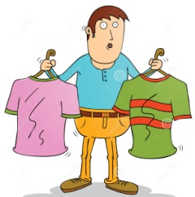
- Oscar : I will buy these T-shirts because they’re on sale.
Rita : Pardon me?
Oscar : I mean ----.

- I’ll pay half the price
- they’re really expensive
- I need some grocery items
- there is no discount

- Louis : ----?
Marc : I attend a course to learn playing the piano.

- What do you do in your free time
- Do you pay any money for this course
- Will you have a discount for this
- How much did you pay for your piano

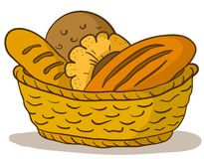
- Where do you go to buy bread?

- Bakery B) Library
- Café D) Chemist’s

- Lola : There is a fire on my neighbor’s house.
What should I do?
Billy : ----.

- Try to save your money.
- You should dial 110 immediately.
- You can be a firefighter.
- Attend a course at the weekend.

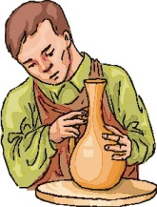
- Robert attends to a(n) ---- course.

- football B) ceramics
- wood painting D) instrument

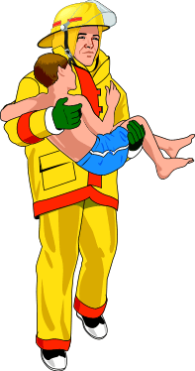
- The firefighter rescued the kid from the fire. He was a(n) ---- man.

- brave B) proud
- governor D) instructor

- Isaac : Where did you go an hour ago?
Rita : To the bookstore.
Isaac : Why did you go?
Rita : ----.

- To buy some medicine for my sister
- To go for a walk in the park
- To buy some CDs for my homework
- To see the new movie

- You should call 112 in Turkey ----.

- to go for a walk in the park
- if you want to post your letters
- to ask help from the police
- if you have a health problem

- Lola :Where is my history book, mom?
Mom : ----.

- I didn’t see it today
- You should look at your bag
- It’s here on the shelf
- You aren’t a careful girl

