KARKUCAK SECONDARY SCHOOL
2nd TERM 2nd WRITTEN EXAM for 8th GRADERS
Name & Surname: Class & Number: MARK:

ANSWER THE QUESTIONS (SORULARI CEVAPLAYIN)
1-2. Soruları aşağıdaki görsele göre cevaplayın.
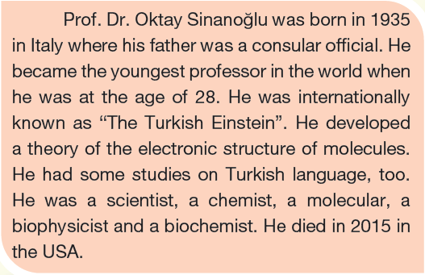
1- When did Oktay Sinanoğlu die?
A) He became a professor at the age of 28.
B) He was born in 1935.
C) He died in 2015.
D) His father was a consular offical.
2- When did he become a professor?
A) He became the youngest professor in 2015.
B) He became a professor in 1963
C) He was born in 1935
D) He became a professor in 1928
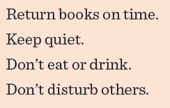
3- Choose the best title.
A) Classroom rules
B) House rules
C) School rules
D) Library rules
4- Aziz Sancar won the Nobel Price in _____ in 2015.
A) chemisrty
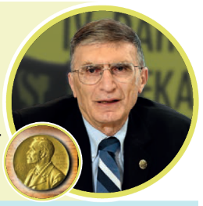
B) biology
C) physics
D) mathematics
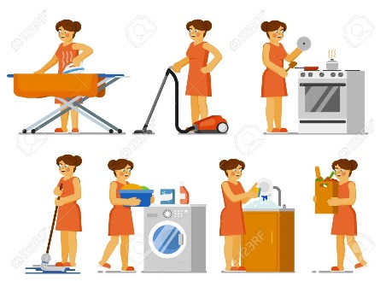
5- Which chores is NOT shown on the picture below?
A) mopping
B) ironing
C) dusting
D) cooking

6- We must stop ________.
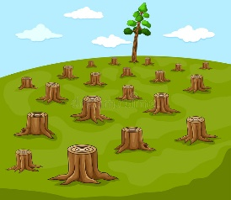
A) deforestation
B) flood
C) landslide
D) earthquake
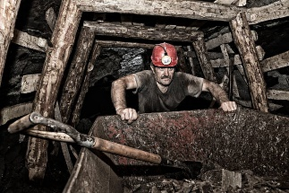
7- My father is __________.
A) a soldier
B) a coal miner
C) an electrician
D) a fire fighter

8- Benjamin Franklin ______ the electricity.
A) discovery B) discovered
C) explored D) invented

9- Which of the following chores is NOT on this picture?
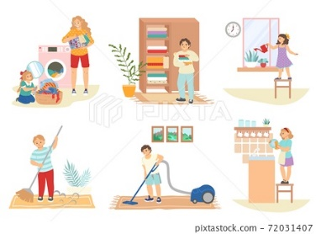
A) vacuum the floor
B) do the laundry
C) sweep the floor
D) load the dishwasher

10- My favourite extreme sport is _________. I like exploring mysterious places.
A) canoeing B) scuba diving
C) caving D) motorbike racing
11- What is the synonym of "well-known"?
A) famous B) well-built
C) put through D) honest

12 – I visited a/an _____________ in Çanakkale.
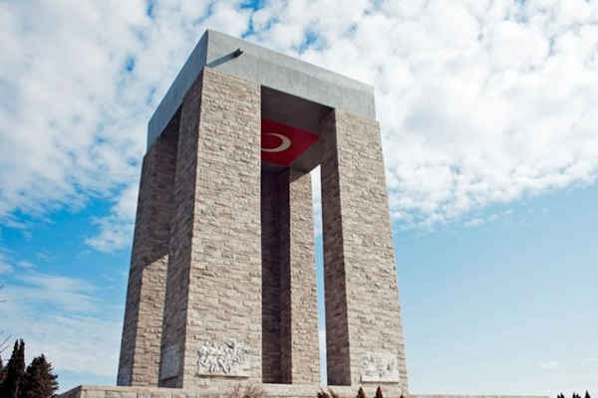
A) ancient places
B) historic places
C) counrtyside
D) monument

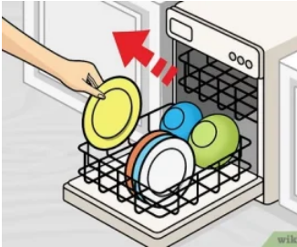
13- My little sister, Seda, is in charge of _____.
A) emptying the dishwasher
B) doing the dishwasher
C) washing the dishes
D) loading the dishwasher

14- Charles Babbage ____ the first computer in 1822.
A) invention B) discovered
C) discovery D) invented

15- My brother, Berat Ali, is responsible for ______.
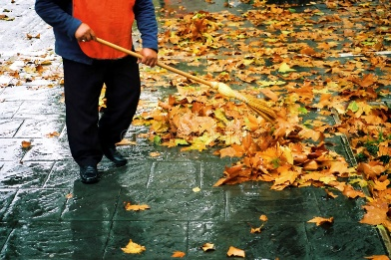
A) vacuuming the leaves
B) sweeping the leaves
C) mopping the floor
D) take out the garbage

16- Which of the following tourist attractions is NOT mentiponed on the picture below?
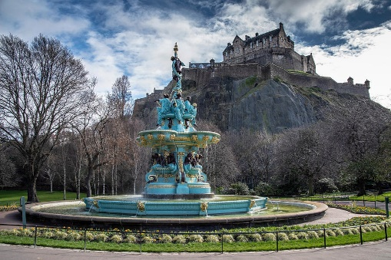
A) mountain
B) castle
C) fountain
D) lake

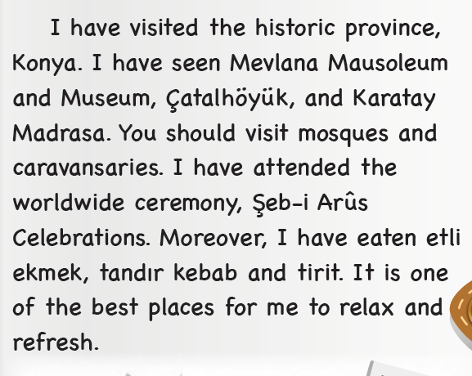
17 ve 18. Soruları alttaki parçaya göre cevaplayınız.
17- What can you taste in Konya?
A) Mevlana Mausoleum B) Şeb-i Arus
C) Karatay Madrasa D) Etli ekmek
18- What is the worldwide ceremony in Konya?
A) Mevlana Mausoleum B) Şeb-i Arus
C) Karatay Madrasa D) Etli ekmek

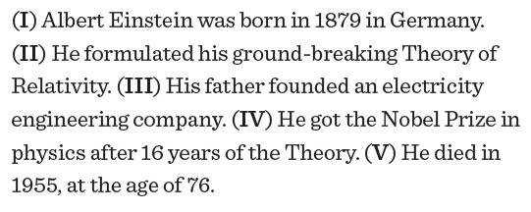
19- Find the ODD sentence.
A) I B) II
C) III D) IV
20- Find the ODD sentence.
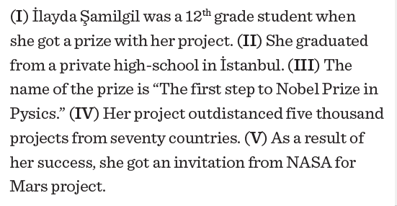
A) I B) II
C) III D) IV

