KARKUCAK SECONDARY SCHOOL
2nd TERM 2nd WRITTEN EXAM for 7th GRADERS
Name & Surname: Class & Number: MARK:

ANSWER THE QUESTIONS (SORULARI CEVAPLAYIN)
(Her doğru cevap 5 puan değerindedir.)
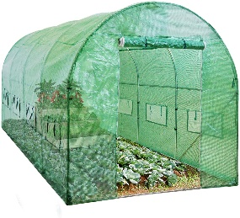
1- We should protect our world from ______ effect.
A) deforestation
B) pollution
C) solar
D) greenhouse
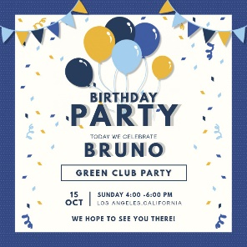
2- We will prepare ___ to invite our guests to my birthday party.
A) invitation card
B) birthday cake
C) confetti
D) candles
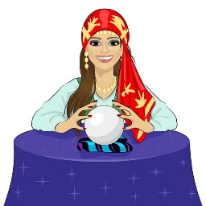
3- I visited the fortune teller to see what will happen in ________.
A) home
B) future
C) space
D) school
4- Görseldeki kelime aşağıdakilerden hangisidir?
A) nuclear waste
B) pesticides
C) recycle
D) wind energy
5- You can _____ at the boutique.
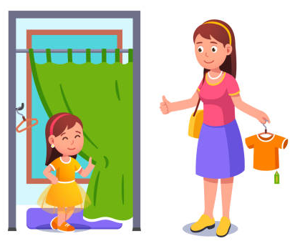
A) try on clothes
B) exhibit paintings
C) draw money
D) borrow books

6- He went to _____________. Because he wanted to have breakfast but there wasn't any bread left.
A) greengrocer’s
B) pharmacy
C) bakery
D) municipality

7- He went to __________. Because he lost his wallet while shopping.
A) shopping mall
B) boutique
C) fire station
D) police station

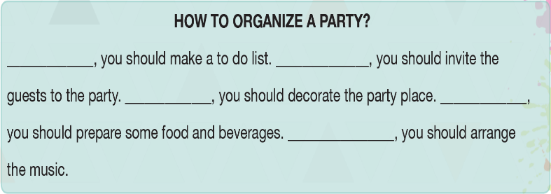
8- Yukarıdaki görselde boş bırakılan yerleri tamamlayan şık hangisidir?
A) first - second - finally - then - and then
B) first - second - then - and then - finally
C) first - then - second - and then - finally
D) then - second - and then - first - finally

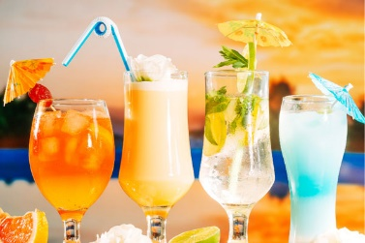
9- “the drinks” eşanlamlısı hangisidir?
A) presents
B) decorations
C) beverages
D) dresses

10- Where can you go to draw money?
A) park B) art gallery
C) hospital D) bank

11- Görseldeki kelime aşağıdakilerden hangisidir?
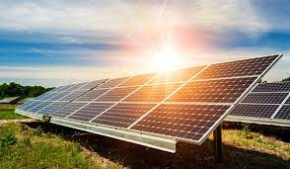
A) air energy
B) wind energy
C) solar energy
D) land energy

12 – We must stop ____ to protect the environment.
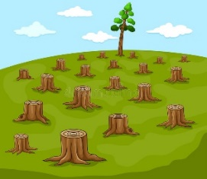
A) deforestation
B) global warming
C) nuclear waste
D) land pollution

13- I went to the bookshop ___________.
A) to report a fire
B) to draw money
C) to have fun with kids
D) to buy a sport magazine

14- In my 20S, I will ______.
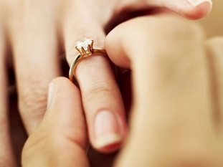
A) go on education
B) get engaged
C) travel
D) be retired

15- Sinem went to ____________. Because she needed to send a parcel to her friend.
A) hospital
B) police station
C) post office
D) shopping mall
16- In 2050, Abdulsamet will________.
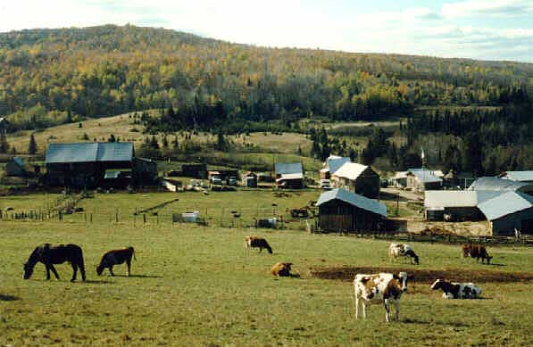
A) run his own business
B) buy a house
C) live in a village
D) go to university

17- What kind of party will you prepare?
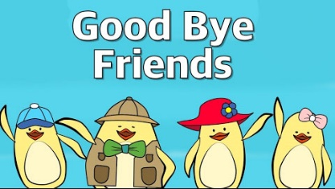
A) birthday party
B) slumber party
C) engagement party
D) farewell party

18- We celebrate _____ every year.
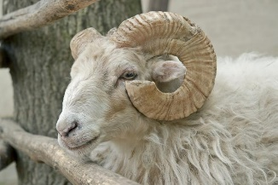
A) ramadan feast
B) sacrifice feast
C) slumber party
D) wedding anniversary

19- Where can you go to report a crime?
A) coffee shop B) fire station
C) pharmacy D) police station

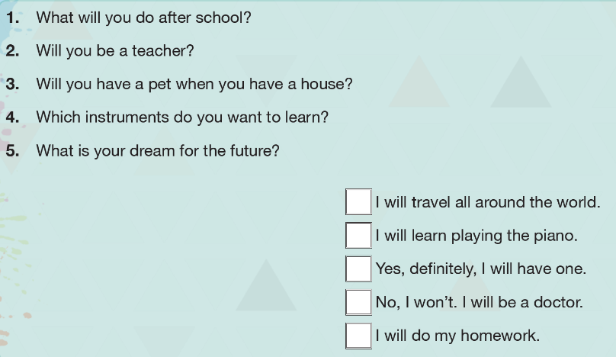
20- Yukarıdaki eşleştirmenin doğru şıkkı hangisidir?
A) 5-4-3-2-1
B) 5-3-4-2-1
C) 1-2-3-4-5
D) 5-4-3-1-2

