- Jill : What kind of films do you like?
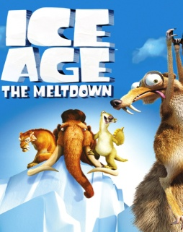
Bill : I like - - - -.

- comedies
- horrors
- adventures
- cartoons

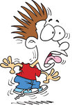
- I don’t like horror films because they are ----.
- funny
- comic
- frightening
- ugly

- Tina : Shall we go to the cinema tomorrow?
Mark : ----.
Tina : See you in front of the cinema, then.

- I see C) It sounds boring
- That’s a good idea D) I feel tired

- Smurfette is very ---- and ----.
- beautiful / talkative
- sweet / cruel
- strong /sweet
- beautiful / sensitive

- Spiderman is a ---- and ----character.

- friendly / lazy C) strong / brave
- cruel / honest D) kind / boring

- My favorite smurf character is Papa Smurf but I don’t like Brainy Smurf because he is very ----.
- brave
- talkative
- strong
- kind

- Luis : Do you know Gargamel?
Rosa : No, I dont. What’s he like?
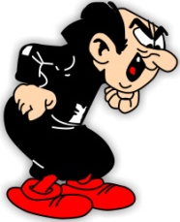
Luis : He is very - - - - . He wants to catch and eat the smurfs.

- brave B) talkative
- friendly D) cruel

- Leo : What’s the main character like?
Bill : - - - -.

- It is The Lion King
- It is on Saturday night
- She is a sensitive girl
- She is in front of the cinema

- Paul : What’s the matter with you?
Lily : I have a stomachache.
Paul : - - - - .
Lily : Thank you.

- I feel terrible C) Get well soon
- Hımm, let me see D) I don’t know

- Sam : What’s the matter with him?
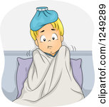
Jim : He - - - -.

- has the measles
- feels hot
- has a sore throat
- feels cold

- He has a backache. So, he ----.
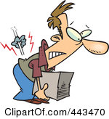
- should do sports
- shouldn’t stay in bed and rest
- shouldn’t carry heavy things
- should go to work

- Aşağıdaki cümleler kim için söylenmiş olabilir?
- Stay in your bed and rest.
- Take your medicine.
- Don’t drink cold drinks.
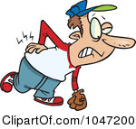
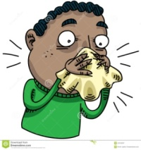
- B)

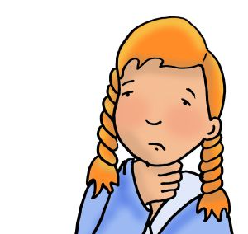
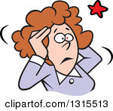
- D)

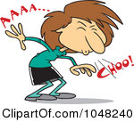
- What’s the matter with her?

- She has a backache.
- She feels hot.
- She has a toothache.
- She sneezes.

- Bob : What does he need?
Tim : - - - -.

- He needs some tissues
- He should see a doctor
- He has a terrible cough
- He should rest in bed

How bad! How do you feel?
I am ill. I have a cold. - - - -.

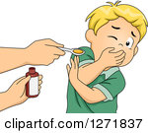

- What should he do?

- He should see a dentist
- He should wash his hands
- He should take his syrup
- He should eat healthy food

You have a fever. - - - - .
Oh, That’s too bad.

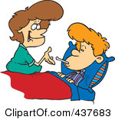

- Don’t be late to school
- You shouldn’t take your medicine
- You shouldn’t stay at home today
- Don’t worry, you’ll be OK

- Paragrafın akışını bozan cümleyi işaretleyiniz.

- Arthur isn’t in the classroom today because he is ill. (II) He has a sore throat. (III) He should drink cold drinks. (IV) He shouldn’t miss his meals. (IV) He should stay in his bed and rest.

- II B) III C)IV D) V

- I have flu. I feel ----. I need ----. I should stay at home.

- tired / tissues C) good / rest
- hurt / blanket D) bad / a dentist

- David : The film starts at 6 o’clock. Shall we meet in front of the cinema?
Sandy : Alright.
David : - - - - .

- Great! See you then C) It sounds boring
- That’s a bad idea D) I don’t know, either

- Daisy : Why don’t we go to the cinema?
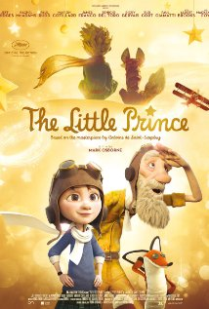
Mina : Sounds great! What’s on the cinema?
Daisy : The Little Prince.
Mina : - - - -?
Daisy : Animation
- Who is the main character
- Which movie is it
- What type of movie is it
- What time does it start

