[](http://www.clipartof.com/portfolio/toonaday/illustration/male-police-officer-eating-a-donut-1198051.html)[](http://www.clipartof.com/portfolio/toonaday/illustration/cartoon-male-auto-mechanic-tossing-a-wrench-443837.html)

10

[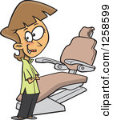](http://www.clipartof.com/portfolio/toonaday/illustration/cartoon-caucasian-female-dentist-by-a-chair-1258599.html)[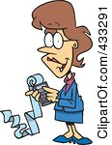](http://www.clipartof.com/portfolio/toonaday/illustration/female-cartoon-accountant-holding-a-calculator-with-a-long-strip-of-paper-433291.html)[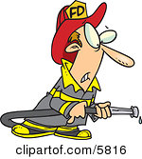](http://www.clipartof.com/portfolio/toonaday/illustration/fireman-in-uniform-holding-a-hose-5816.html)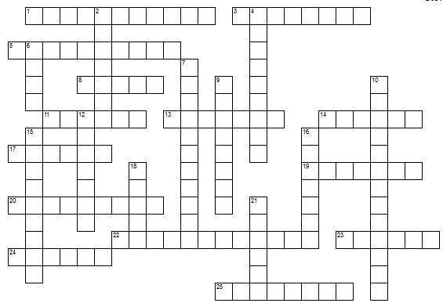[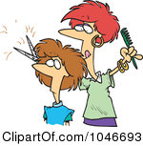](http://www.clipartof.com/portfolio/toonaday/illustration/cartoon-woman-cutting-hair-at-a-salon-1046693.html)

9

7

5

4

[](http://www.clipartof.com/portfolio/toonaday/illustration/male-engineer-with-blueprints-and-tools-1164742.html)

6

2

[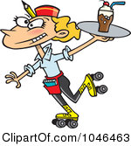](http://www.clipartof.com/portfolio/toonaday/illustration/cartoon-car-hop-waitress-on-skates-1046463.html)[](http://www.clipartof.com/portfolio/toonaday/illustration/happy-male-nurse-carrying-a-clipboard-1164730.html)[](http://www.clipartof.com/portfolio/toonaday/illustration/proud-helicopter-pilot-man-standing-by-his-chopper-1112496.html)[](http://www.clipartof.com/portfolio/toonaday/illustration/male-chef-tossing-pizza-dough-into-the-air-5835.html)

1

11

[](http://www.clipartof.com/portfolio/toonaday/illustration/cartoon-judge-leaning-over-his-desk-438069.html)[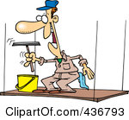](http://www.clipartof.com/portfolio/toonaday/illustration/window-washer-on-a-platform-436793.html)

12

8

3

[](http://www.clipartof.com/portfolio/toonaday/illustration/weed-warrior-woman-standing-proud-with-a-rake-435874.html)[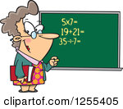](http://www.clipartof.com/portfolio/toonaday/illustration/caucasian-female-math-teacher-at-a-chalk-board-1255405.html)

24

25

14

13

[](http://www.clipartof.com/portfolio/toonaday/illustration/female-vet-using-a-stethoscope-on-a-dog-436837.html)[](http://www.clipartof.com/portfolio/toonaday/illustration/male-butler-carrying-a-cupcake-with-a-lit-candle-on-a-tray-5807.html)[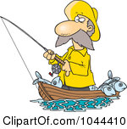](http://www.clipartof.com/portfolio/toonaday/illustration/cartoon-fisherman-standing-in-his-boat-1044410.html)[](http://www.clipartof.com/portfolio/toonaday/illustration/cartoon-seamstress-sewing-1046814.html)

23

15

[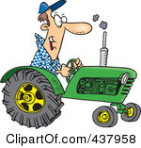](http://www.clipartof.com/portfolio/toonaday/illustration/cartoon-tractor-driver-437958.html)

22

16

[](http://www.clipartof.com/portfolio/toonaday/illustration/cartoon-elvis-impersonator-singing-439831.html)[](http://www.clipartof.com/portfolio/toonaday/illustration/cartoon-tired-mail-man-carrying-a-big-bag-443074.html)

21

17

[](http://www.clipartof.com/portfolio/toonaday/illustration/cartoon-secretary-filing-her-nails-at-her-desk-438961.html)[](http://www.clipartof.com/portfolio/toonaday/illustration/caucasian-school-boy-running-with-his-accessories-1255407.html)[](http://www.clipartof.com/portfolio/toonaday/illustration/cartoon-grim-nurse-holding-a-syringe-and-hammer-440145.html)

20

19

18

**Answer Key**

