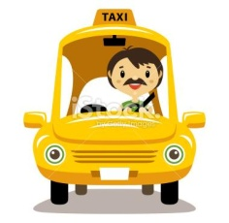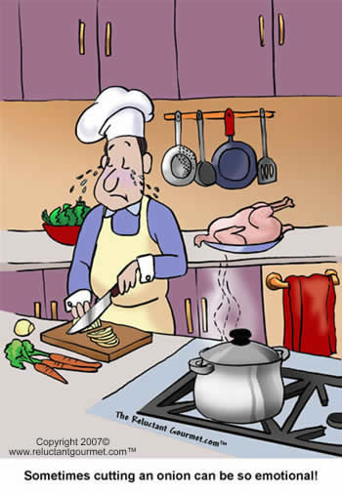

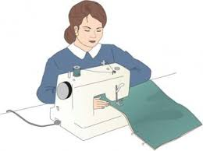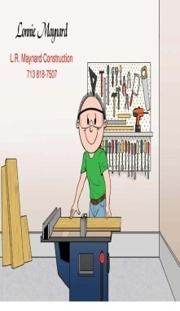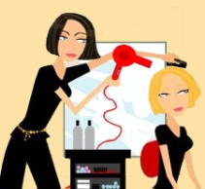

**Write the names into the blanks.**

1- _______ designs and draws building plans.

2- _______ cuts and sews dresses, trousers, skirts etc.

3- _______ cuts, dyes, designs hair.

4- _______ flies a plane/cargo/people from one place to another.

5- _______ repairs electrical devices.

6- _______ cooks dishes in a hotel.

7- _______ drives people from one place to another.

8- _______ answers the telephones and writes letters/e-mails.

9- _______ works for the army.

10- _______ treats decayed teeth.

11- _______ performs rhythmic and artistic movements.

12- _______ vacuums and cleans houses, dusts the furniture.

13- _______ treats ill animals.

14- _______ cuts, shapes and installs building materials.

15- _______ grows fruits and vegetables.

16- _______ collects and writes news.

17- _______ extinguishes fires, responds to emergency situations.

18- _______ ensures the safety and comfort of the passengers during the flight.

Jill

Mike

Sam

Sherry

Tom

Sally

Betty

Sue

Emily

Sheila

Ann

David

Eliza

Adam







Dave

Kim

**What do they do? (Circle “a” or “an”)**

1- Janet is a/an ______________.

2- Sally is a/an ______________.

3- Adam is a/an ______________.

4- Eliza is a/an ______________.

5- Betty is a/an ______________.

6- Fred is a/an ______________.

7- Emily is a/an ______________.

8- Sue is a/an ______________.

9- Tom is a/an ______________.

10- Kim is a/an ______________.

11- Jill is a/an ______________.

12- Mike is a/an ______________.

13- Sam is a/an ______________.

14- Sherry is a/an ______________.

15- Dave is a/an ______________.

16- Sheila is a/an ______________.

17- Ann is a/an ______________.

18- David is a/an ______________.

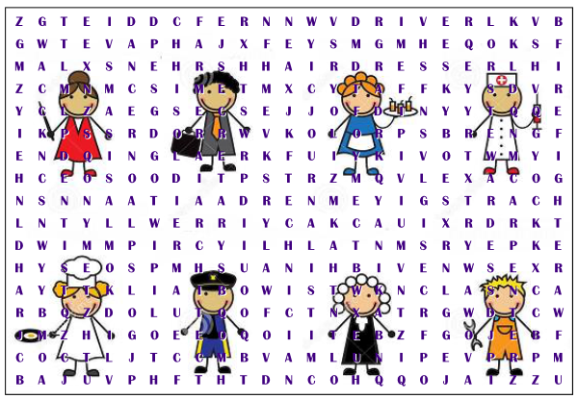**Find the words you used above in the puzzle.**

ANSWER KEY



**Write the names into the blanks.**

1- **BETTY** designs and draws building plans.

2- **EMILY** cuts and sews dresses, trousers, skirts etc.

3- **ANN** cuts, dyes, designs hair.

4- **DAVID** flies a plane/cargo/people from one place to another.

5- **JILL** repairs electrical devices.

6- **ADAM** cooks dishes in a hotel.

7- **FRED** drives people from one place to another.

8- **SHERRY** answers the telephones and writes letters/e-mails.

9- **SHEILA** works for the army.

10- **MIKE** treats decayed teeth.

11- **ELIZA** performs rhythmic and artistic movements.

12- **SUE** vacuums and cleans houses, dusts the furniture.

13- **SALLY** treats ill animals.

14- **TOM** cuts, shapes and installs building materials.

15- **DAVE** grows fruits and vegetables.

16- **SAM** collects and writes news.

17- **KIM** extinguishes fires, responds to emergency situations.

18- **JANET** ensures the safety and comfort of the passengers during the flight.

Jill

Mike

Sam

Sherry

Tom

Sally

Betty

Sue

Emily

Sheila

Ann

David

Eliza

Adam







Dave

Kim

**What do they do? (Circle “a” or “an”)**

1- Janet is **a**/an **stewardess**.

2- Sally is **a**/an **vet**.

3- Adam is **a**/an **cook**.

4- Eliza is **a**/an **dancer**.

5- Betty is a/**an** **architect**.

6- Fred is **a**/an **driver**.

7- Emily is **a**/an **tailor**.

8- Sue is **a**/an **cleaner**.

9- Tom is **a**/an **carpenter**.

10- Kim is **a**/an **firefighter**.

11- Jill is **a**/an **technician**.

12- Mike is **a**/an **dentist**.

13- Sam is **a**/an **journalist**.

14- Sherry is **a**/an **secretary**.

15- Dave is **a**/an **farmer**.

16- Sheila is **a**/an **soldier**.

17- Ann is **a**/an **hairdresser**.

18- David is **a**/an **pilot**.

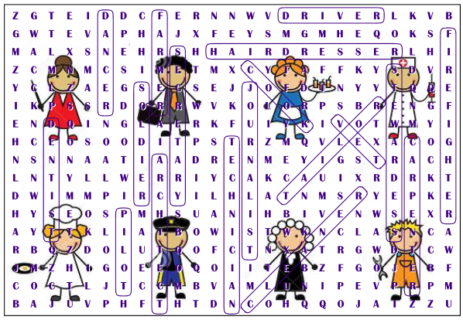**Find the words you used above in the puzzle.**