**2021-2022 EDUCATION YEAR KARKUCAK SECONDARY SCHOOL**

**6th GRADES 1st TERM 2nd ENGLISH EXAM**

**Name, Surname:__________________________ Number: _________ Class: _________**

**A. Write seasons.** *(Mevsimleri yazınız*.) 4x2=8 points

**Summer - Winter - Autumn - Spring**

**[](http://www.clipart.com/en/close-up?o=3965712&memlevel=A&a=a&q=snowman&k_mode=all&s=1&e=21&show=&c=&cid=&findincat=&g=&cc=&page=&k_exc=&pubid=)[](http://www.clipart.com/en/close-up?o=2912133&memlevel=C&a=a&q=spring&k_mode=all&s=190&e=210&show=&c=&cid=&findincat=&g=&cc=&page=10&k_exc=&pubid=)[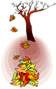](http://www.clipart.com/en/close-up?o=3976715&memlevel=A&a=a&q=autumn&k_mode=all&s=43&e=63&show=&c=&cid=&findincat=&g=&cc=&page=3&k_exc=&pubid=)[](http://www.clipart.com/en/close-up?o=3805605&memlevel=A&a=a&q=summer&k_mode=all&s=232&e=252&show=&c=&cid=&findincat=&g=&cc=&page=12&k_exc=&pubid=)**

**1._________________ 2.__________________ 3.________________ 4.______________**

**B. Fill in the blanks according to the picture.** *(Resme göre boşlukları şehirlerle doldurunuz*.) 8x2=16 points

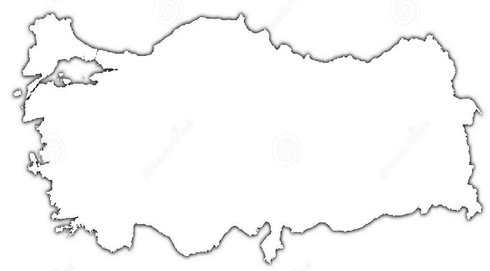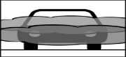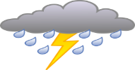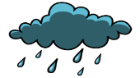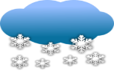

İstanbul 5°C

Van -7°C

Rize 12°C

Diyarbakır 4°C

İzmir 7°C

Ankara 8°C

Antalya 20°C

1)The weather is **sunny** in __________________ 5)It is **rainy** in __________________

2)It is **snowy** in _________________ 6)It is **foggy** in __________________

3)It is **stormy** in __________________ 7)It is **windy** in __________________

4)The weather is **cloudy** in __________________ 8) Rize is **colder** than ______________

**C.Write emotions.** *(Resimlerin altına verilen duygu durumlarından uygun olanı yazınız.)*7x2=14 points

|  |
| --- |
| **Adsız.png sleepy / scared / ~~excited~~ / angry / happy / energetic / tired / sad**  **excited** |

**D. Match the words with pictures.** *(Kelimelerle resimleri eşleştiriniz.)*(8x2=16p)

*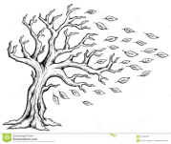stormy –snowy – windy – rainy – freezing – cloudy – sunny – foggy*

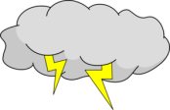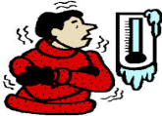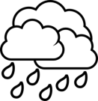

**E. Choose the correct option. (46 points)**

|  |  |
| --- | --- |
| **1.** **good / easy/ bad / far**  Sıfatlarının comperative hali hangi şıkta **doğru** olarak verilmiştir?  **a)** gooder – easier – worse - farther  **b)** better – easier – badder - farther  **c)** better – easyer – worse - farther  **d)** better – easier – worse - farther | **5. Which one is Jack’s breakfast ?**  Jack has cheese ,olives ,egg and bagel at breakfast. Also,tea is his favourite. He *dislikes* sausages.  A) http://www.clker.com/cliparts/c/4/a/c/1197099096631359336dStulle_brown_egg.svg.hi.pnghttp://www.bradfitzpatrick.com/shop/images/products/fb030-cotton-bagel-clipart.jpghttp://www.impratea.co.ke/images/tea_cup.pnghttp://www.medolico.com/upfiles/Image/Olives/olive01.jpghttp://images.clipartpanda.com/cheese-20clip-20art-cheese-slice-Download-Royalty-free-Vector-File-EPS-1687.jpg B) http://images.clipartpanda.com/cheese-20clip-20art-cheese-slice-Download-Royalty-free-Vector-File-EPS-1687.jpghttp://images.clipartpanda.com/sausage-clipart-sausages-clip-art.jpghttp://www.medolico.com/upfiles/Image/Olives/olive01.jpghttp://www.bradfitzpatrick.com/shop/images/products/fb030-cotton-bagel-clipart.jpg  C) http://www.bradfitzpatrick.com/shop/images/products/fb030-cotton-bagel-clipart.jpghttp://images.clipartpanda.com/cheese-20clip-20art-cheese-slice-Download-Royalty-free-Vector-File-EPS-1687.jpghttp://www.zerowasteweek.co.uk/wp-content/uploads/formidable/cereal-leftovers-recipe-zero-waste-week.jpghttp://www.clker.com/cliparts/c/4/a/c/1197099096631359336dStulle_brown_egg.svg.hi.png D) http://www.alternet.org/files/story_images/bread.pnghttp://www.clker.com/cliparts/c/4/a/c/1197099096631359336dStulle_brown_egg.svg.hi.pnghttp://images.clipartpanda.com/cheese-20clip-20art-cheese-slice-Download-Royalty-free-Vector-File-EPS-1687.jpghttp://www.impratea.co.ke/images/tea_cup.pnghttp://www.medolico.com/upfiles/Image/Olives/olive01.jpg |
| **2- Tom:** Where is the car park?  **Buse:** It’s ______ the mall.   |  | | --- | |  |     **a)** in front of  **b)** behind  **c)** opposite  **d)** next to | **6- My school starts at ___________.**  **a)** quarter to nine  **b)** half past seven  **c)** quarter past six  **d)** half past ten |
| **clocks ile ilgili görsel sonucu3.** **Helen : What time do you go to bed ?**  **Katty :I sleep at ________**  A) quarter past ten  B) ten o’clock  C) ten to ten  D) ten past ten | **7.** downtown–skyscraper-crowded-farm  **Aşağıdakilerden hangisi yukarıda verilen İngilizce kelimelerin anlamlarından birisi değildir?**  a. Gökdelen b. Kalabalık  c. Şehir merkezi d. Şehir |
| **4- My mother is ……………………….than me. (beautiful)**   1. beautiful b) beautifuller 2. more beautiful d) more beautiful than | **8-**  **a)** happy  **b)** angry  **c)** He is fine  **d)** He is from France |

*Testteki 1, 2 ve 3. Sorular 6’şar puan diğer sorular 5 puandır. Boş bırakmayınız. Başarılar dilerim.*

*Ali Akdere*