FLAG (BAYRAKLAR) | IN TURKISH | COUNTRY | NATIONALITY | CONTINENT
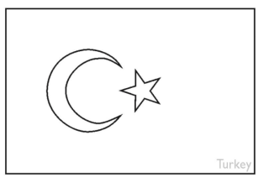 | TÜRKİYE  - | TURKEY  -  -  - | TURKISH  -  -  - | EUROPE AND ASIA
 | AMERİKA  - | THE USA / AMERICA  -  -  - | AMERICAN  -  -  - | AMERICA
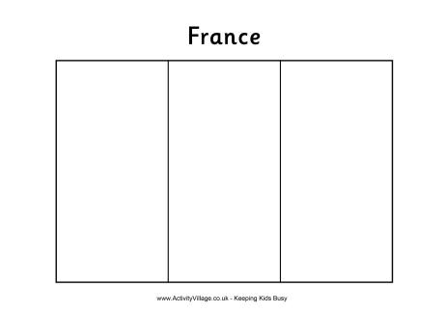 | FRANSA  - | FRANCE  -  -  - | FRENCH  -  -  - | EUROPE
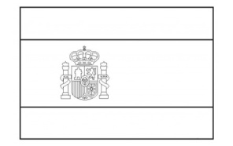 | İSPANYA  - | SPAIN  -  -  - | SPANISH  -  -  - | EUROPE
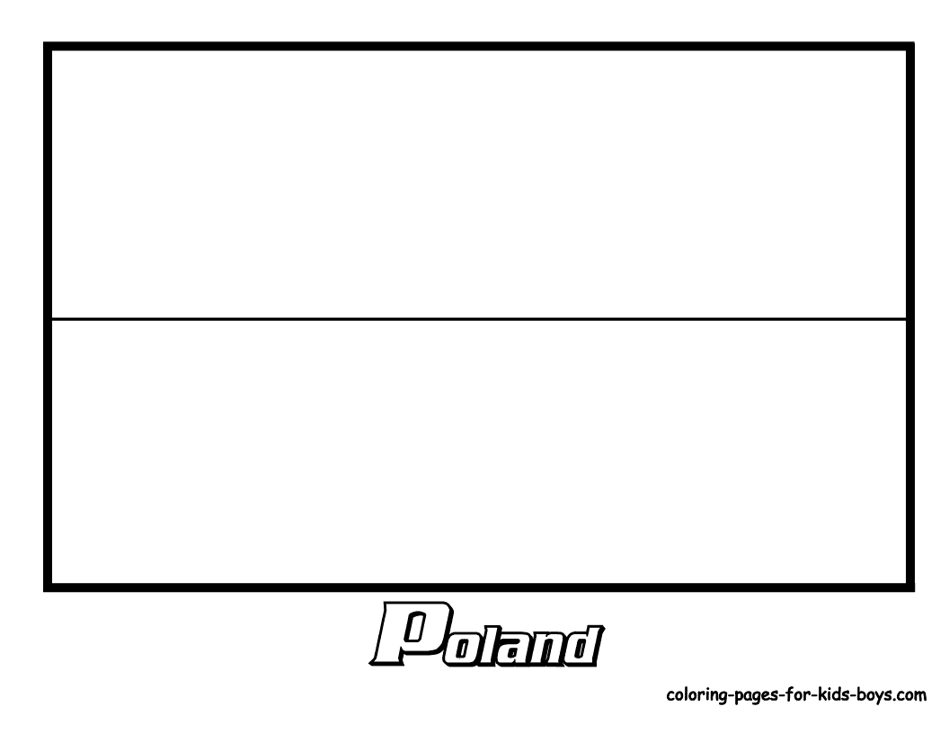 | POLONYA  - | POLAND  -  -  - | POLISH  -  -  - | EUROPE
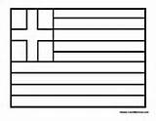 | YUNANİSTAN  - | GREECE  -  -  - | GREEEK  -  -  - | EUROPE
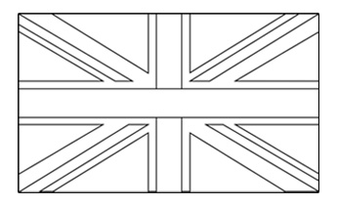 | İNGİLTERE  - | ENGLAND  -  -  - | ENGLISH / BRITISH  -  -  - | EUROPE
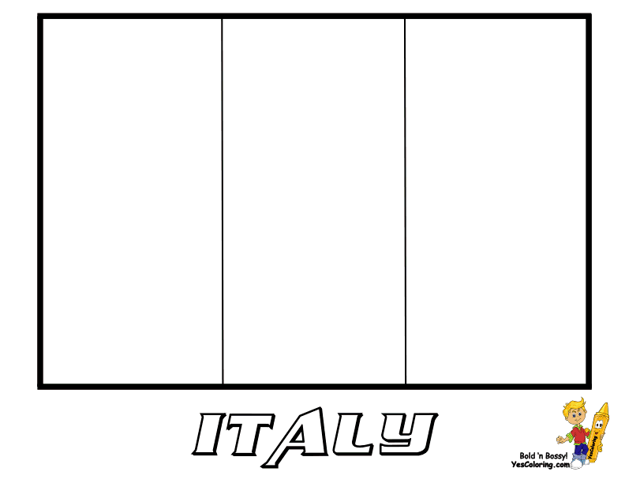 | İTALYA  - | ITALY  -  -  - | ITALIAN  -  -  - | EUROPE
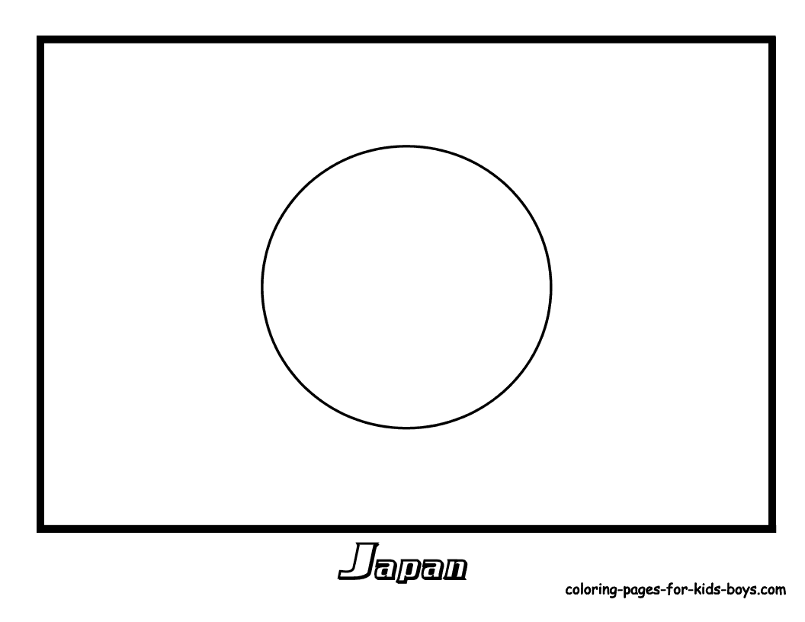 | JAPONYA  - | JAPAN  -  -  - | JAPANESE  -  -  - | ASIA
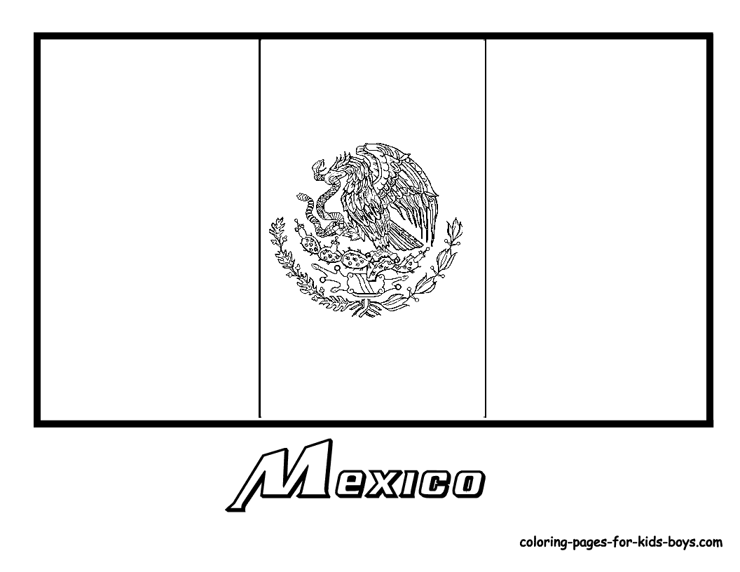 | MEKSİKA  - | MEXICO  -  -  - | MEXICAN  -  -  - | NORTH AMERICA
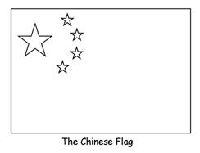 | ÇİN  - | CHINA  -  -  - | CHINESE  -  -  - | ASIA
 | HİNDİSTAN  - | INDIA  -  -  - | INDIAN  -  -  - | ASIA
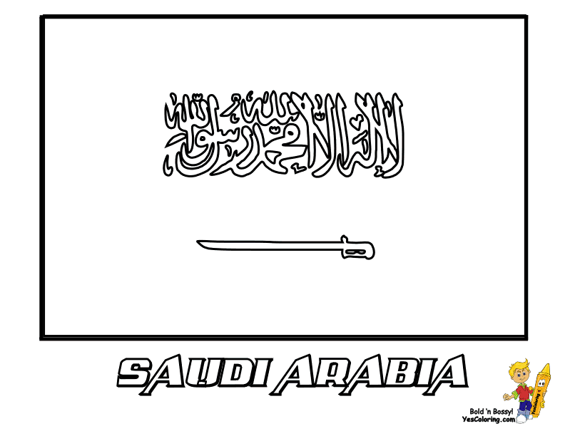 | SUUDİ ARABİSTAN  - | SAUDI ARABIA  -  -  - | SAUDI ARABIAN  -  -  - | AFRICA
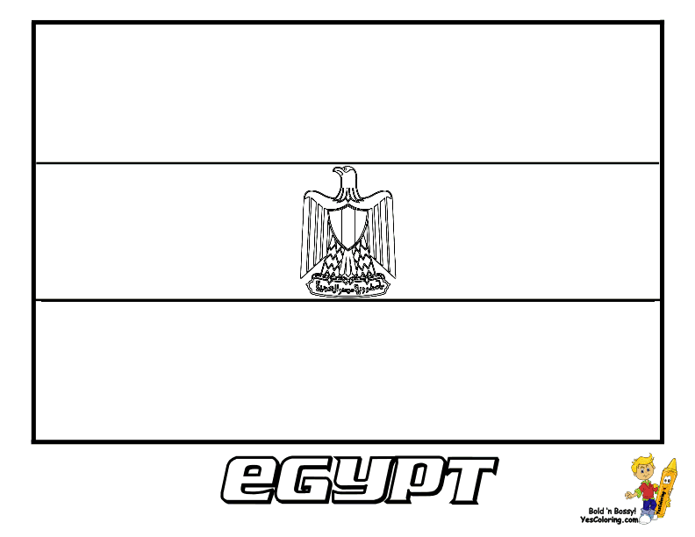 | MISIR  - | EGYPT  -  -  - | EGYPTIAN  -  -  - | AFRICA
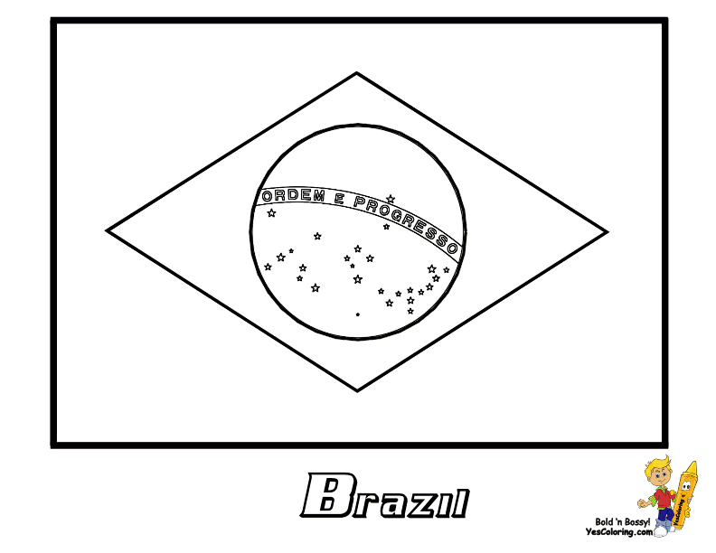 | BREZİLYA  - | BRAZIL  -  -  - | BRAZILIAN  -  -  - | SOUTH AMERICA
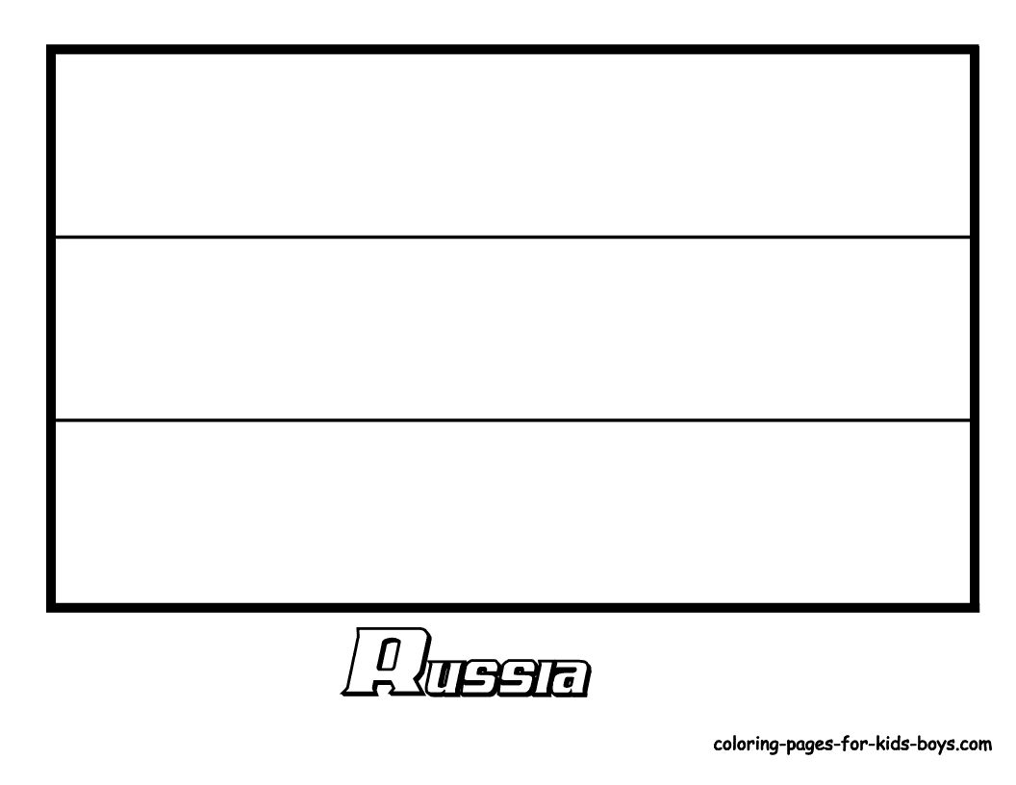 | RUSYA  - | RUSSIA  -  -  - | RUSSIAN  -  -  - | EUROPE AND ASIA
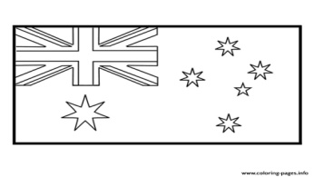 | AVUSTRALYA  - | AUSTRALIA  -  -  - | AUSTRALIAN  -  -  - | AUSTRALIA
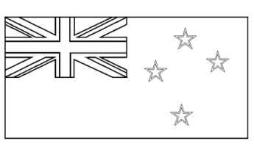 | YENİ ZELANDA  - | NEW ZEALAND  -  -  - | NEW ZEALANDER  -  -  - | AUSTRALIA
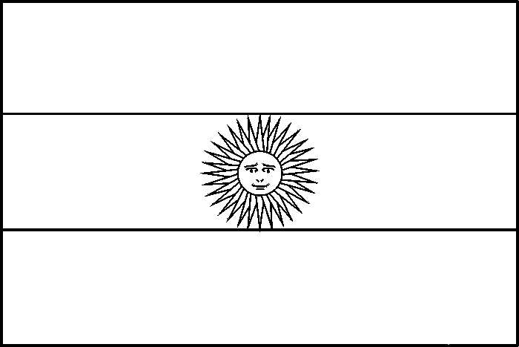 | ARJANTİN  - | ARGENTINA  -  -  - | ARGENTINIAN  -  -  - | SOUTH AMERICA
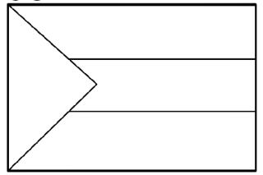 | SUDAN  - | SUDAN  -  -  - | SUDANESE  -  -  - | AFRICA
 | ALMANYA  - | GERMANY  -  -  - | GERMAN  -  -  - | EUROPE
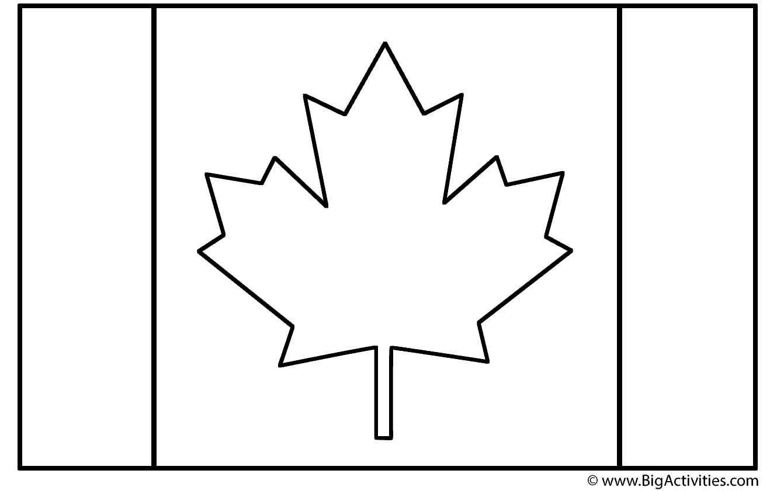 | KANADA  - | CANADA  -  -  - | CANADIAN  -  -  - | NORTH AMERICA

HOMEWORK / ÖDEV : BAYRAKLARI DOĞRU ŞEKİLDE BOYA VERİLEN BOŞLUKLARA KELİMELERİ TEKRARDAN YAZ.

