**2021-2022 KARKUCAK SECONDARY SCHOOL 1ST TERM 2ND EXAM FOR 5TH GRADES**

NAME: ………………………………………….. CLASS: 5/… NUMBER:……….

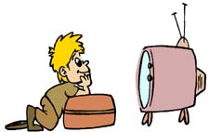

|  |  |  |
| --- | --- | --- |
|  | COUNTRY | NATIONALITY |
| A | TURKEY | TURKISH |
| B | ENGLAND | ENGLISH |
| C | ITALIAN | ITALY |
| D | SPAIN | SPANISH |

1. Hangi eşleştirme yanlıştır?
2. A:……………………….?

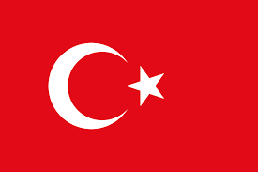B: She is from Turkiye.

1. Where is she from?
2. Where is the school?
3. What is your name?
4. What is your favorite game?

My favorite class is Art.

I like Maths and Physical Education too but I don’t like Science.

1. Yukarıda hangi dersten bahsedilmemiştir?

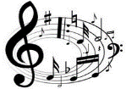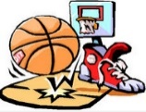a. b. c. d.

***4 ve 5. Soruları aşağıdaki tabloya göre yanıtlayın***

|  |  |  |  |
| --- | --- | --- | --- |
|  | **MONDAY** | **TUESDAY** | **WEDNESDAY** |
| **JACK** | Maths 😊 | English😊 | Computer ☹ |
| **SALLY** | Maths 😊 | Art 😊 | English☹ |

1. **Tabloya göre hangisi doğrudur?**
2. Jack has computer on Tuesday.
3. Jack has Art on Monday.
4. Jack has Maths on Monday.
5. Sally has computer on Monday
6. **Tabloya göre hangisi doğrudur?**
7. Sally likes Computer
8. Jack doesn’t like English
9. Sally doesn’t like Maths
10. Jack and Sally likes Maths
11. I …… watching T.V
12. Love
13. Like
14. Can
15. Dislike

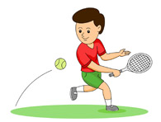

1. Görsellere göre doğru cümle hangisidir?
2. He likes swimming and tennis
3. He likes tennis.
4. He doesn’t like swimming
5. He likes swimming

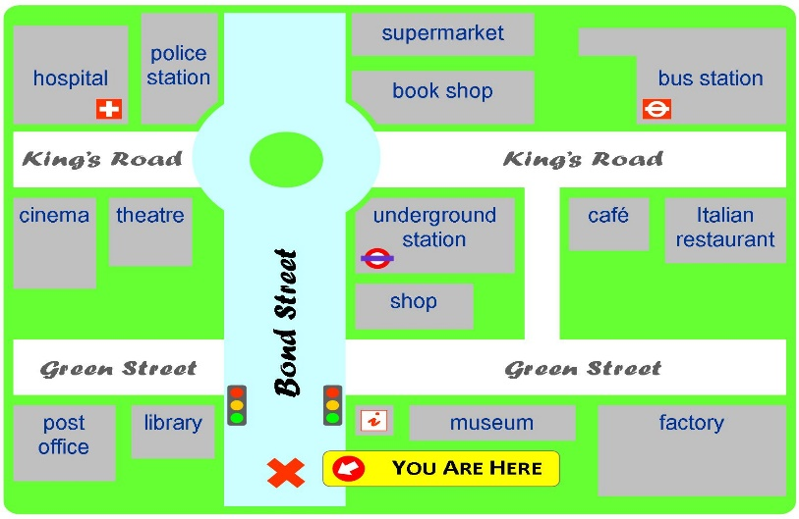 **8,9 ve 10. Soruları aşağıdaki haritaya göre cevaplayın**

1. **Ali: Where is the cinema?**

**Ayşe: It is ………… the hospital.**

1. Next to b) Near c) Opposite d) Under
2. **Ayşe: Where is the Italian Restaurant?**

**Ali: It is near the……….**

1. Library b) Cafe c) Museum d) Theatre
2. **- How can I go to the ……….?**

- Go straight ahead Bond Street.

Take the second right into King’s Road.

Go straight ahead King’s Road. It is on your left, opposite the Italian Restaurant.

1. Bus station
2. Lilbrary
3. Hospital
4. Post Office

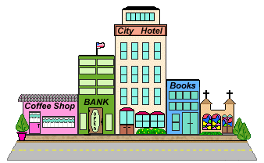

1. **Where is the City Hotel?**
2. Opposite the bank
3. Between the coffee shop and bank
4. Between the bank and books
5. Next to the coffee shop
6. 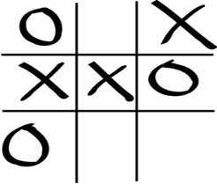**Görseli ifade eden şık hangisidir?**
7. Checkers
8. Chess
9. Domino
10. Tic tac toe
11. **Görseli ifade eden hobi hangisidir?**
12. Do origami
13. Play drum
14. Collect stamps
15. Play tennis

I like playing hangman, playing hopscotch and playing chess but my favorite game is leapfrog.

1. Yukarıda hangi oyundan **bahsedilmemiştir**?
2. [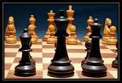](http://images.google.com.tr/imgres?imgurl=http://www3.telus.net/chessvancouver/images/chess.jpg&imgrefurl=http://www3.telus.net/chessvancouver/&usg=__ejM2Q7qFlnV62E_wmppz1aoy8mg=&h=550&w=800&sz=64&hl=tr&start=1&tbnid=XvX2roFS1d_91M:&tbnh=98&tbnw=143&prev=/images?q=CHESS&gbv=2&hl=tr)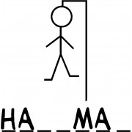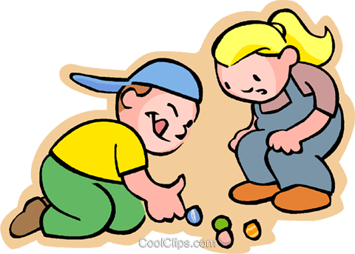 b) c) d)

|  |
| --- |
| **Ali**: …………………………..?  **Ayşe**: My favorite hobby is camping. |

1. Ali hangi soruyu sormalıdır?
2. What is your nationality?
3. What is your name?
4. What is your best clour?
5. What is your favorite hobby?
6. Resimdeki sayının İngilizcesi hangisidir?
7. 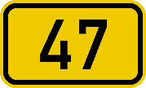Seventy-four
8. Fourty-seven
9. Sixty-six
10. twenty one
11. 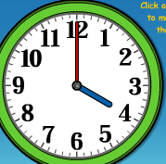What time is it?

It is …………

1. Two o’clock.
2. Four o’clock
3. Ten o’clock
4. Six o’clock
5. Görseldeki oyun nedir?

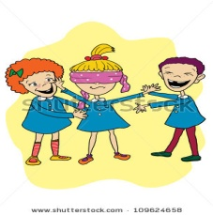

a) Hangman

b) Chinese Whisper

c) Blind Man’s Buff

d) Playing Marbles

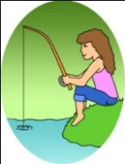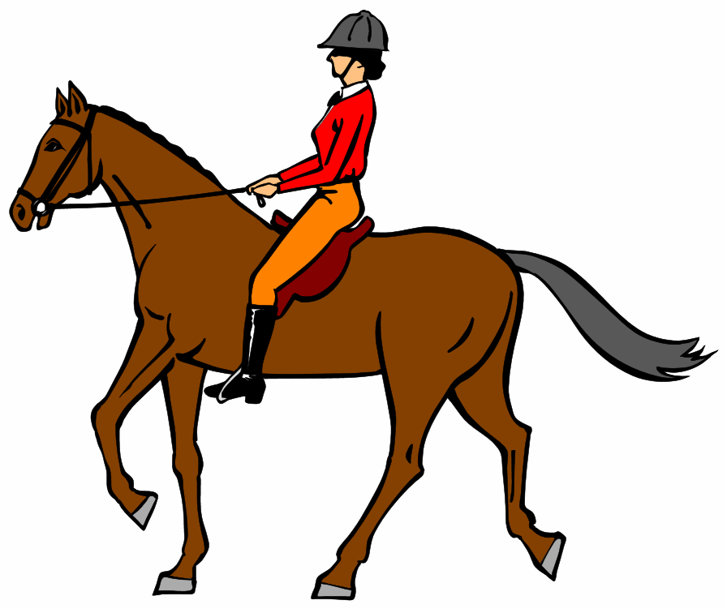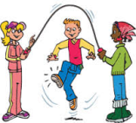

1. Yukarıdaki resimleri doğru sırayla anlatan şık hangisidir?
2. Skip rope - ride horse – go fishing
3. Skip Rope - do origami – ride horse
4. Play chess - ride horse – do origami
5. Ride horse – go fishing – skip rope



1. Yukarıdaki şeklin anlamı nedir?
2. Go straight
3. Turn right
4. Turn left
5. Go ahead

Ali AKDERE

😊 English Teacher😊