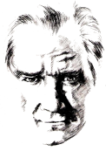 |  | AVLAK  SECONDARY SCHOOL  2023-2024 EDUCATIONAL YEAR  7TH GRADERS’ 1ST TERM 2ND WRITTEN EXAM
 | Name-Surname: |  | Class 7/A -Number: | POINT:
- Read Atatürk’s life and answer the questions. (Atatürk’ün hayatını okuyunuz ve soruları cevaplayınız). (2X5= 10 Points)

E7.3.R1. Students will be able to spot specific information about names and dates in past events in written texts.
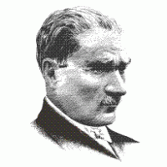
Mustafa Kemal was born in 1881 in Salonica. His father’s name was Ali Rıza Efendi and his mother’s name was Zübeyde Hanım. His sister's name was Makbule. He went to Samsun on 19th May 1919. Because he started the War of Independence. He opened the Turkish Grand National Assembly on 23rd April 1920. Turkish Grand National Assembly (TBMM) gave him surname Atatürk. He founded the Republic Of Turkey. He was elected the first president of the Turkish Republic. He died at 09.05, on 10th November 1938 and his grave is in Anıtkabir, Ankara.
1-) When was Atatürk born? …………………………………………………………………………………
2-) Where was Atatürk born? …………………………………………………………………………………
3-) Why did he go to Samsun? …………………………………………………………………………………
4-) Who gave him surname Atatürk? …………………………………………………………………………………
5-) What time did he die? …………………………………………………………………………………

E7.4.R1. Students will be able to understand past and present events in simple texts including explanations and reasons.
- Read the text and answer the questions. (Metni okuyun ve soruları cevaplayın.) (2X5= 10 Points)
Hello, I’m Doris. I’m an athlete. I get up early every day. I usually eat a big breakfast, and then I go to the gym. I sometimes exercise in the gym, but I train in the field more often. I never do heavy exercises not to hurt my legs.

- What’s Doris’s job? …………………………………………………………………………………
- When does Doris get up? …………………………………………………………………………………
- Where does Doris go after a big breakfast? …………………………………………………………………………………
- How often does Doris exercise in the gym? …………………………………………………………………………………
- Why does Doris never do heavy exercises? …………………………………………………………………………………

E7.1.W1. Students will be able to write simple pieces to compare people.
- Read the sentences and write down the comparative forms of adjectives correctly. (Cümleleri okuyun ve sıfatların karşılaştırma hallerini doğru bir şekilde yazın.) (2X5= 10 Points)
  - Tina is than Carl (generous).
  - My uncle is than my father (old).
  - Duygu’s hair is than my hair (long).
  - Jack is than Sandy (smart).
  - Jane is than Katie. (beautiful)

E7.3.W1. Students will be able to write a short and simple report about past events.
D) Read the chart and write the hours according to the David’s Weekly Activities. (Tabloyu okuyun ve David’in haftalık etkinliklerine göre sıklık zarflarını yazın.) (5X5=25 Points)
David’s Weekly Activities
Frequency | always | usually | sometimes | seldom | never
Activity | 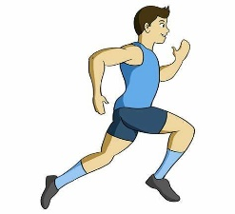 |  |  | 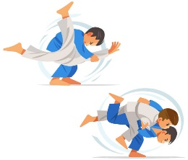

1- David ………………………………… does judo.
2-David …………………………………. goes cycling.
3-David…………………………………. goes skiing.
4-David…………………………………. goes running.
5- David…………………………………. plays tennis.

E7.1.W1. Students will be able to write simple dates of the years.
- Write the years in NUMBERS. (Yılları sayı olarak yazın.) (5X5= 25 Points)

1. ……..:Eighteen- sixty-three
2. …….. :Nineteen eighty-eight
3 . …….. :Twenty thirteen
4. ……..:Fourteen fifty-three
5. ……..:Two thousand twenty-three

E8.3.R2. Students will be able to guess the meaning of unknown words.

- Write the Turkish meanings of given words. (Verilen kelimelerin Türkçe anlamlarını yazınız.) (2X10= 20 Points)
- Attend: …………………………………………………………………………………
- Award: …………………………………………………………………………………
- Brilliant: ………………………………………………………………………………
- Get engaged: ………………………………………………………………………
- Get married: ………………………………………………………………………
- Invent: …………………………………………………………………………………
- Graduate: ……………………………………………………………………………
- Grow up: ……………………………………………………………………………
- Move: …………………………………………………………………………………
- Raise: …………………………………………………………………………………
ENGLISH LANGUAGE TEACHER: SERKAN ALAN GOOD LUCK 😊

