1. Fred is a soldier. He works for the army.
A) B) C) D)

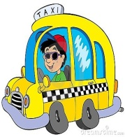
2. Alex ______ people from one place to another.
A) sews B) drives
C) performs D) treats

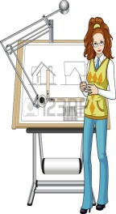
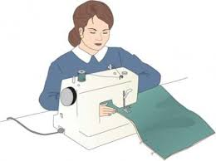
3. Betty designs and draws building plans.
A) B) C) D)

4. Eliza has lunch ___ 1p.m. at the school canteen every weekday.
A) on B) in C) at D) to

5. Linda ________ early on weekdays.
A) brushes her teeth
B) wakes up
C) has breakfast
D) gets dressed

6. Brenda is a nurse and she works at a ________.

A) hospital B) school
C) science-lab D) spaceship

7. Rose writes letters and e-mails. She answers the telephones and organizes meetings. She is a _________.
A) stewardess B) secretary
C) actress D) economist

I meet my customers, listen to their needs and take notes.
8.
_______?

A) What’s your dream work?
B) What is your favorite job?
C) What do you do at work?
D) Do you work every day?

9. Dave : ________?
Mike : She’s a nurse.

A) How old is Sheila?
B) Is Sheila a nurse?
C) When does she go to hospital?
D) What’s Sheila’s job?

I ____ my e-mails before I ______ work every day.
10.

A) check / start B) wear / stop
C) sew / arrive D) mend / put on

111. Emily is interested ___ cooking. She cooks dishes ___ a restaurant.
A) at / in B) in / in
C) in / on D) at / on

112. George is a/an ________. He repairs electrical devices.
A) architect B) farmer
C) hairdresser D) technician

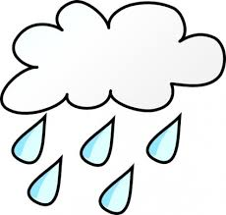
- Yesterday Today
- It is partly cloudy today, but it was rainy yesterday.
- It is partly cloudy yesterday, but it was rainy today.
- It is rainy yesterday, but it was partly cloudy today.
- It was partly cloudy yesterday, but it is rainy today.
- Aşağıdaki resim-açıklama eşleştirmelerinden hangisi yanlıştır?
- He went diving yesterday. | - He went ice-skating last winter.
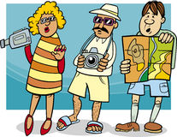
- The tourists went sightseeing in city centre. | - He picked apples in the garden.

- A: When did you visit your uncle?
B: __________.

- Always B) Tomorrow
- Last week D) Now

16. An astronaut can use __________.

A) fabrics B) prescriptions
C) a spaceship D) a survey

He/she cuts, dies and designs hair.

What does a/an _______ do?

17.

A) pilot B) policeman
C) mechanic D) hairdresser

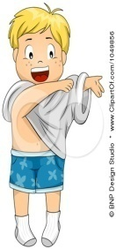
18. Steve gets up, has breakfast, _____ and leaves home in 20 minutes.

A) gets dressed B) has shower
C) cooks dishes D) walks to work

I’m a _______.
119.

A) sales person B) cleaner
C) translator D) journalist

120.
I am a tailor. I ______.

A) work at a school
B) can write computer programmes
C) teach maths
D) can cut and sew fabrics

