- Write the names of activities under the pictures. Resimlerin altına etkinliklerin harfini yazınız. (10x3=30p)

- Rest
- Help dad
- Run errands
- Take care of the pet
- Do homework
- Visit grandmother
- Take folk dance courses
- Have lunch
- Play tennis
- Go to school
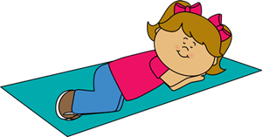

- Draw the hands of the clock according to the given time. (Altta yazan saatlere göre boş saatlere doğru saati çiziniz.) (6x3=18p)

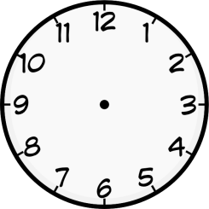
A B C D E F

- It is nine o’clock.
- It is ten past ten.
- It is twenty-five past eight.
- It is half past three.
- It is twenty to five.
- It is five to one.

- TRUE or FALSE (Parçaya göre aşağıdaki cümleler doğruysa (T) yanlışsa (F) yazınız. (6x2=12p)

Gloria is 12 years old. She is a student in the sixth grade. She wakes up at seven o’clock. She has breakfast at quarter past seven. She goes to school at quarter to eight. Her lessons start at
eight-thirty. After school, she takes a nap at two p.m. Then, she visits her grandmother at half past four and she takes care of her cat at twenty past five. She finishes all her homework at ten to nine. She goes to bed at ten p.m.

(……………) Gloria wakes up at nine o’clock.
(……………) She has breakfast at quarter past seven.
(……………) She goes to school at 7:45 a.m.
(……………) She visits her uncle at 4:30 p.m.
(……………) She finishes her homework at ten to nine.
(……………) She takes care of her dog at twenty to five.
4 - Use ‘in’ , ‘on’ , ‘at’ (in,on, at’i kullanınız) (6x3=18p.)

1.My birthday is _ _ _ _ _ _ Sunday | 2.Aslı eats a hamburger _ _ _ _ _ _ _ _ _ noon
3.I drink coffee _ _ _ _ _ _ _ _ _ _ the mornings. | 4.We are _ _ _ _ _ _ _ _ _ _ _ 2019
5.I go to bed _ _ _ _ _ _ _ _ _ _ _ 9:00 o’clock | 6.Eda goes to the course _ _ _ _ _ __ weekdays

5 - Write the years (Yılların okunuşlarını yazınız) (4x3=12p.)
1901 : _ _ _ _ _ _ _ _ _ _ _ _ _ _ _ _ _ _ _ _ _ _ _ _ _ _ _
2020 : _ _ _ _ _ _ _ _ _ _ _ _ _ _ _ _ _ _ _ _ _ _ _ _ _ _ _
2009 : _ _ _ _ _ _ _ _ _ _ _ _ _ _ _ _ _ _ _ _ _ _ _ _ _ _ _
1110 : _ _ _ _ _ _ _ _ _ _ _ _ _ _ _ _ _ _ _ _ _ _ _ _ _ _ _

6- Write the dates. (Okunuşları verilmiş tarihleri yazınız.) (5x2=10p.)
Örnek: the twentieth of June, nineteen twenty: …………………..20.06.1920……………….

1 - the nineteenth of May, nineteen nineteen: _____________________________
2 - the sixth of September, twenty twenty: _______________________________
3 – the fourth of January, twenty ten: ________________________________
4 – the eleventh of March, nineteen eleven: ______________________________
5 – the first of August, twenty twelve: ___________________________________
Ali AKDERE
English Teacher Good Luck!!!
Süre: 40 dk.

