Name/ Sur name: Score Correct: False:
- Arthur: Wat did you do last summer?
Anıl: I ____ to the seaside and ___.
- stayed/ visited B) went/ swam C) tried/ learned D) sang/ lost

- Jack: Oh, James! What happened?
James: I broke my leg.
Jack: How did you break your leg?
James: ____________.
- I learned paragliding last week. B) I tried sailing. C) I fell yesterday. D) I borrowed a book.

- Which one is false Verb1 – Verb2 matching?
- sing – song B) lend – lent C) study – studied D) buy – bought

- ___ a book from the library/ ____ in a tent/ ____ home
- read/ live/ lend B) call/ talk/ learn C) borrow/ stay/ arrive D) fall/ hurt/ try
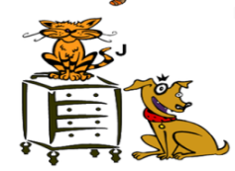
- Which one is true?
- The cat is in front of the drawer.
- The dog is under the drawer.
- The drawer is under the cat, near the dog.
- The drawer is between the cat and the dog.

- (I) I love reading books. (II) You english book is on the desk. (III) I’m a bookworm. (IV) I always go to the library.
Hangisi anlam akışını bozmaktadır?
- I B) II C) III D) IV
- Kevin: I ______ my keys. I can’t find them.
Camelia: Oh, Did you look under your bed?
Kevin: Ok. I _____ my keys! Thanks you.
Camelia: You are welcome.
- fell/ hurt B) borrowed/ lent C) called/ talked D) lost/ found

- İkinci halleri göz önüne alındığında hangisi farklıdır?
- read B) stay C) pick D) climb

- I ____ dinner two hours ago and _____ tea half an hour ago.
- ate/ drink B) eat/ drink C) drank/ ate D) drink/ eat

Names | yesterday | an hour ago
Nicole | read novel | pick flowers
Zeynep | feed pets | buy books
Kerem | visit museum | swim
Tom | learn diving | try sailing

Which one is true?
- Zeynep bought books yesterday. C) Nicole picked flowers last summer.
- Kerem visited a museum an hour ago. D) Tom tried sailing an hour ago.

- Buse: Did you ____ your brother an yesterday?
Fred: I _____ him but he didn’t answer the phone.
- call/ called B) called/ call C) fall/ fell D) fell/ fall
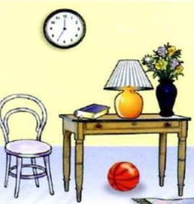
- Which one is wrong?

- The ball is under the table. C) The book is on the table.
- The clock is in the wall. D) The chair is next to the table.
- Simon: ________?
Aylin: They are behind the door.

- Where is my car key? B) Where are the books? C) Where is Kevin? D) Where are you now?

- Betty: When did you ____ to the library?
Kenan: I ____ to the library yesterday.
- went/ go B) go/ went C) going/ go D) go/ goes

- an hour – we – home – arrived - ago
1 2 3 4 5 Verilen kelimeleri kurallı bir cümle oluşturacak şekilde sıralayan şık hangisidir?

- 3 – 1 – 2 – 4 – 5 B) 2 – 3 – 4 – 1 – 5 C) 2 – 1 – 5 – 3 – 5 D) 2 – 4 – 3 – 1 – 5

- My classmates picked flowers in the school garden ____ morning.
- Now B) last C) yesterday D) ago

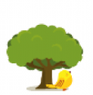
- The bird is over the tree.
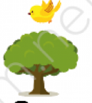
- B) C) D) .

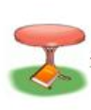
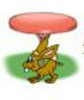
- Which one is true/ correct?
- B) C) D)

The apple is in front of the table. The rabbit is under the table. The book is under the table. The book is under the table.
- Raif: Where were you yesterday?
Pamela: ________
Raif: What did you do there?
Pamel: I had diving course.
- They were at the seaside. B) I was at the pool. C) I went to the library. D) I tried ice- skating.

- Which one is false?
- lake – göl B) seaside – deniz kenarı C) forest – orman D) mountain – bahçe

- Lale: ____ did you go last week?
John: I went to the shopping mall.
- Who B) Why C) When D) Where

- I ___ at home but my friends ___ at the library yesterday.
- was/ were B) were/ was C) ‘m/ are D) are/ ‘m

- Barney: What did you do an hour ago?
Burcu: _____
- I’m reading a book. B) I learn playing chess. C) I like swimming. D) I called my sister.

- Leonardo: Did you try paragliding?
Ekin: ______
Leonardo: How was it?
Ekin: It was wonderful.
- Yes, I did. B) No, I didn’t. C) Yes, I do. D) No, I don’t.

- Derya: Where is my English book?
Tonny: _______
- I’m at home. B) It’s in your school bag. C) You are at the class. D) They are behind the door.

