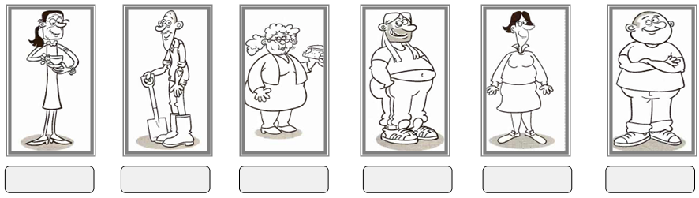
A. Read the descriptions and write the name of the person under the correct picture. (6x3=18 points)

-Sara is fat and short. She has got long curly hair. She has got small ears and small eyes. She wears glasses.
-Peter is tall and thin. He has got no hair. He has got a long face. He has got moustache. His ears are big.
-Kelly is tall and fat. She has got short dark hair. Her eyes are small but her nose is long.
-Tom is tall and fat. He has got long fair hair and beard. He has got big eyes and a big nose. His ears are big, too.
-Alex is fat and tall. He has got no hair. He has got a big nose, big mouth, big head and big eyes.
-Polly is tall and very thin. She has got long dark hair. She has got glasses. Her nose is long.
B. Group the words and phrases according to appearance and personality (22x1=22 points).
well built - short - shy - long - honest - clever - handsome - generous - wavy - beautiful - stubborn - forgetful - beard - thoughtful - medium height - sincere - easygoing - overweight - kind - attractive - moustache - talkative
APPEARANCE | PERSONALITY
1- 7-  2- 8-  3- 9-  4- 10-  5- 11-  6- | 1- 7-  2- 8-  3- 9-  4- 10-  5- 11-  6-
C. Fill in the blanks with the correct personality words (8x2=16 points).
thoughtful | outgoing | clumsy | stubborn
lazy | selfish | generous | punctual

- I can't speak in front of people. I feel nervous when I'm in front of the board. I don't like meeting new people and going out with friends. I think I am not ........................................... .
- My sister always thinks of herself. She doesn't care about other people and she doesn't share her clothes with me. I think she is a .......................................... girl.
- My father is a ................................................. man. He is never late for work. He goes to everywhere on time.
- Mark can't get high marks from the exams. He never listens to teachers carefully. He never does his homework. Because he is a .......................................... student.
- Lisa's new desk mate is ............................................... . She gave half of her sandwich to Lisa and helped Lisa with her homework.
- Betty is a little bit ................................................. . She often drops things on the floor and breaks something.
- Elisabeth often invites us for dinner and gives gifts to us because she is a ........................................... woman.
- My boyfriend is so ..................................... . He never changes his mind. He thinks he is always right.
D. Write the opposites. (7x2=14 points)

1) young x ...................................... 2) fat x .......................................... 3) tall x ......................................
4) handsome x ................................. 5) hardworking x ............................... 6) outgoing x .............................
7) tell the truth x ..................................................

E. Complete the sentences to make comparisons. (5x4=20 points)

1. My grandma sometimes gives me money but my grandpa always gives me a lot of money. (generous)
My grandma is ............................................................... my grandpa.
2. Tony weighs 90 kilograms but Mark weighs 120 kilograms. (fat)
Mark is.......................................................................................
3. Betty has a lot of friends but Sally has only a few friends. Betty loves meeting new people but Sally doesn't. (outgoing)
........................................................................................... than Sally.
4. I can swim well but Mark swims very well. He always wins the gold medal but I always win the bronze medal. (good)
Mark swims..................................................................................... .
5. Ankara is 450 kilometres from Sivas. İstanbul is 900 kilometres from Sivas. (far)
..........................................................................................than Ankara from Sivas.
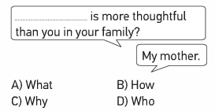
F. Choose the correct choice. (5x2=10 points)

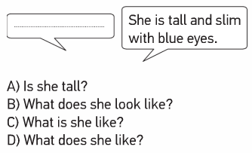
1)

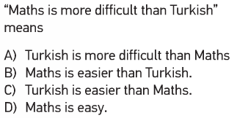
2) Aşağıdaki cümle ile aynı anlama gelen seçenek hangisidir?

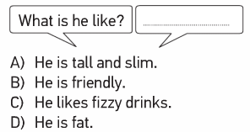
3)

4)

5) Jeremy ............. short and medium weight .......... long dark hair.
A) is / with B) has got / and
C) is / and D) has got / with

