- Write the names of activities under the pictures. (20p)

- Rest
- Help dad
- Run errands
- Take care of the pet
- Do homework
- Visit grandmother
- Take folk dance courses
- Have lunch
- Play tennis
- Go to school
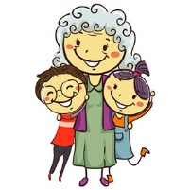
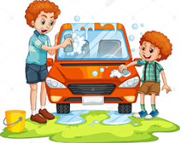
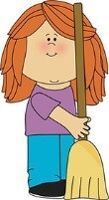
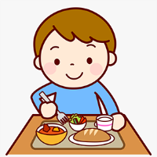
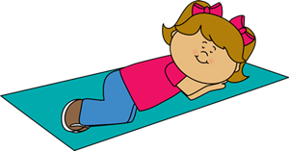
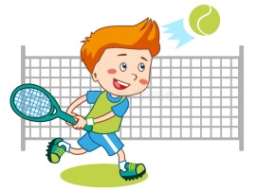
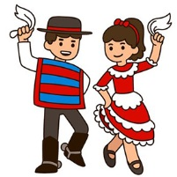
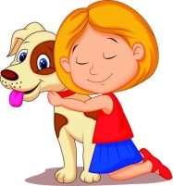

- Write the names of the foods. (15p)

sausages – bread – milk – junk food – fruits – cheese – pancake – muffin – toast – apple juice
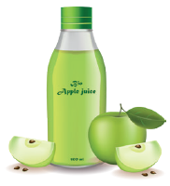
 | 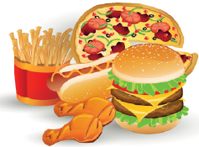  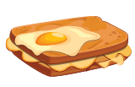 | 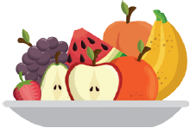 |  | 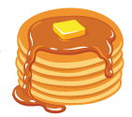
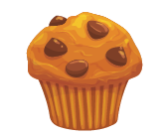 | 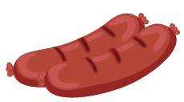 | 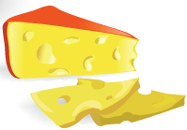 | 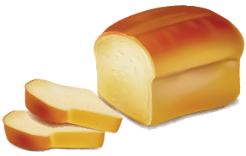 | 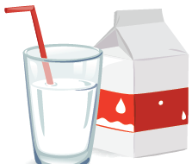

- Put the words in the correct order. (15p)

- is / What / favorite / your / food / ? ........................................................................................................................................

- My father / does / like / not / pancakes / . ..........................................................................................................................

- like / I / and / juice / croissants / apple / . ..........................................................................................................................

- for breakfast? / do / have / we / What / ...............................................................................................................................

- want to / some / Do / lemonade / you / drink / ? .............................................................................................................

- Draw the hands of the clock according to the given time. (16p)

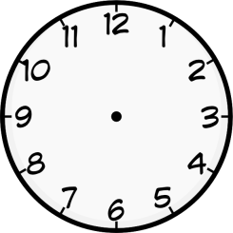
A B C D E F

- It is nine o’clock.
- It is ten past ten.
- It is twenty-five past eight.
- It is half past three.
- It is twenty to five.
- It is five to one.

- Draw smiley faces into the table according to people’s likes and dislikes. (16p)

 | 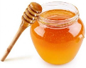 | 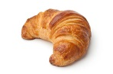 | 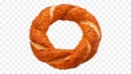 | 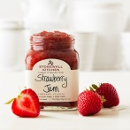 | 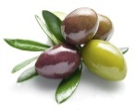 | 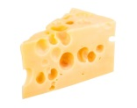 | 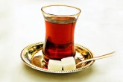 | 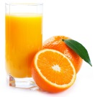
Ayşe
Fatma
Hayriye
Dilara

= likes = doesn’t like

Hello. I’m Ayşe. I like croissants, butter, jam and boiled eggs at breakfast. I don’t like honey or olives.

Hi. I’m Dilara. I like bagel and jam. And I drink tea at breakfast. I don’t like orange juice. .

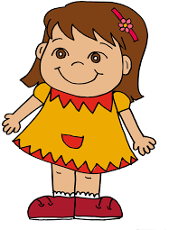
Hello. I’m Hayriye. I like cheese, olives, tomatoes and cucumbers with bread. I like drinking milk. I don’t like
croissants and bagel.

Hi. I’m Fatma. I like muffin, cereal with milk, honey and orange juice at breakfast. I don’t like cheese or tea. .

- TRUE or FALSE (18p)

Gloria is 12 years old. She is a student in the sixth grade. She wakes up at seven o’clock. She has breakfast at quarter past seven. She goes to school at quarter to eight. Her lessons start at
eight-thirty. After school, she takes a nap at two p.m. Then, she visits her grandmother at half past four and she takes care of her cat at twenty past five. She finishes all her homework at ten to nine. She goes to bed at ten p.m.

(……………) Gloria wakes up at nine o’clock.
(……………) She has breakfast after school.
(……………) She goes to school at 7:45 a.m.
(……………) She visits her uncle at 4:30 p.m.
(……………) She finishes her homework at ten to nine.
(……………) She takes care of her dog at twenty to five.

…………………
English Teacher Good Luck!!!
Süre: 30 dk.

