2016-2017 ACADEMIC YEAR …………. SECONDARY SCHOOL 1ST ENGLISH WRITTEN EXAM FOR GRADE 8TH
NAME: SURNAME: CLASS / NO: MARK:

A. MATCH THE WORDS WITH PICTURES. (8x1=8p)
Hiking - bossaball - zorbing - mountain biking - snow tubing - snowshoeing - jogging - camping
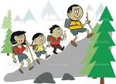
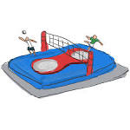

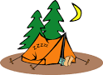
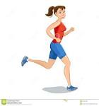
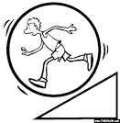

B. READ THE SENTENCES AND FILL IN THE GAPS “INVITE, ACCEPT, REFUSE, EXCUSE” (10x2=20p)
1. I am not feeling well. (………………………….) 6. Why not? (…………………………)
2. Do you want to take a walk with me? (………………………….) 7. I ‘d love to but l can’t. (………………………….)
3. I have nothing better to do. (…………………………..) 8. I am going to go out of city.(………………………..)
4. What about eating pasta? (……………………………..) 9. Maybe later. (……………………………….)
5. I’m busy but l can’t refuse invitation.(………………………) 10. I have to study English. (……………………………..)
C. READ THE SENTENCES ABOUT “ TRUE FRIENDS” AND WRITE “TRUE” or “FALSE .” (8x2=16p)
1. They are like your sisters and brothers. (…………..) 5. You never get on well with them. (………………….)
2. They have nothing in common. (………………..) 6. You sometimes argue. (…………………..)
3. They are great buddies. (……………….) 7. You can always count on them. (………………….)
4. They sometimes lie to you. (………………….) 8. They are strangers. (………………………)
D. READ THE INVITATION AND FILL IN THE GAPS. (6x2=12p)
Who is the sender?
Who is the invitation for?
What is the invitation about?
Who is the party for?
Where is the party?
What time is the party?
Hi, Amanda
I hope all is well in your world!
I am going to throw a surprise birthday party for Kevin. He is turning on 15 on Friday. The party is at my place. It starts at 3 p.m. Would you like to join us? I am sure you are going to have great fun with us.
Cheers
Gamze

E. Suppose that you are Amanda. Reply to the invitation. State that you can’t attend and make an excuse. 4p

F. WRITE THE PARTS OF BIKE. (10p)
Chain
Brake lever
Handlebar
Gear
Seat
Brake
Tire
Mudguard
Pedal
Frame

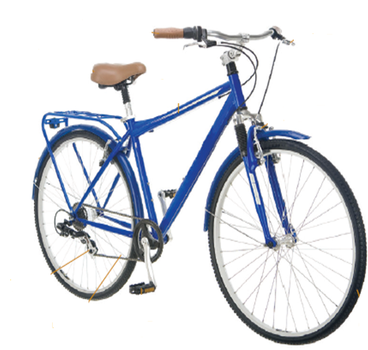

G. COMPLETE THE SENTENCES WITH THE CORRECT VERB FORMS ANSWER THE QUESTİONS. (10p + 8p=18p)
Hi! My name is Kevin. On weekdays, l …………………..(get up) at half past seven and ………………(have) breakfast with my family. We ………………..(have) pancakes , eggs, cheese and tea for breakfast. After breakfast l usually …………………..(walk) to school with my little brother, but my father ………………(drive) to work. He ………………..(work) out of city. In the afternoons, l ……………………..(sing) in the choir and my brother ……………………..(go) to art class.
On weekends, we usually …………………(get up) later, around nine o’clock. We often …………….(go) nature walking.
1. What time does Kevin get up on Sunday?

2. Why does Kevin’s father go to work by car?

3. What does Kevin prefer doing in the afternoons?

4. When do they go nature walking?

H. PUT THE WORDS IN CORRECT GAPS. 12p
Far away - impressive - bad habits - unbearable - sci-fi movies - loud

1. l can’t hear the singer because the band is very …………………………… .
2. I love Taylor Swift’s songs. I think she has an ……………………………….. voice.
3. I can’t stand listenin to heavy metal. In my opinion, it’s really …………………………. .
4. I always walk to school because it is not …………………………..from my place.
5. You always go to bed late, eat a lot of junk food and never do exercise. You have some …………………………..
6. I am not really into ………………..................., especially the ones about the space and travelling through time.

….. / 10 / 2016 GOOD LUCK!!!

English Teacher

